Formatting guidelines for authors submitting initial abstract for  41st EARSeL Symposium 2022  (Style: Title abstract) |  | EARSeL Cyprus 2022  Abstract  Corresponding Author:  cyprus2022@earsel.org
Roy Orbison¹, Second Author², Third Author³, Fourth Author⁴
(Style: Authors, presenting author underlined)
¹ University of xxx, Department of xxx, Belgium
²University of XXXXXX, Country
³ University of XXXXXX, Country
⁴ University of XXXXXX, Country
Keywords (5): EARSeL 2022, abstract, formatting guidelines

The challenge (max. 1000 characters space incl.)
This document serves as a formatting template for authors submitting an abstract to the 41st EARSeL Symposium. It contains all the necessary style elements for you to prepare the abstract in the preferred format. This abstract will be used to assist the organizers in selecting papers for presentation and posters and in designing the programme. The abstract should contain 4500 – 5000 characters and four sections: The challenge (max. 1000 characters space incl.), Methodology (max. 1500 characters space incl.), Results (max. 1500 characters space incl.) and Outlook for the future (max. 1000 characters space incl.). It does not normally contain references. One figure shall be provided at the end of the text. As in the example below, the Figure should be centred and occupy the whole space without any text on the right and left-hand sides. Graphics should have an adequate resolution (min 300 dpi.). The document itself is set out using the layout and styles for the abstract. Your abstract should be saved in a file named as follows: “ID_EARSeL_Cyprus2022.docx”. The ID of your presentation is given on ConfTool. The document is required to be uploaded in the Conference tool to be considered for review.
Methodology (max. 1500 characters space incl.)
Fill in content.
Results (max. 1500 characters space incl.)
Fill in content.
Outlook for the future (max. 1000 characters space incl.)
Fill in content.
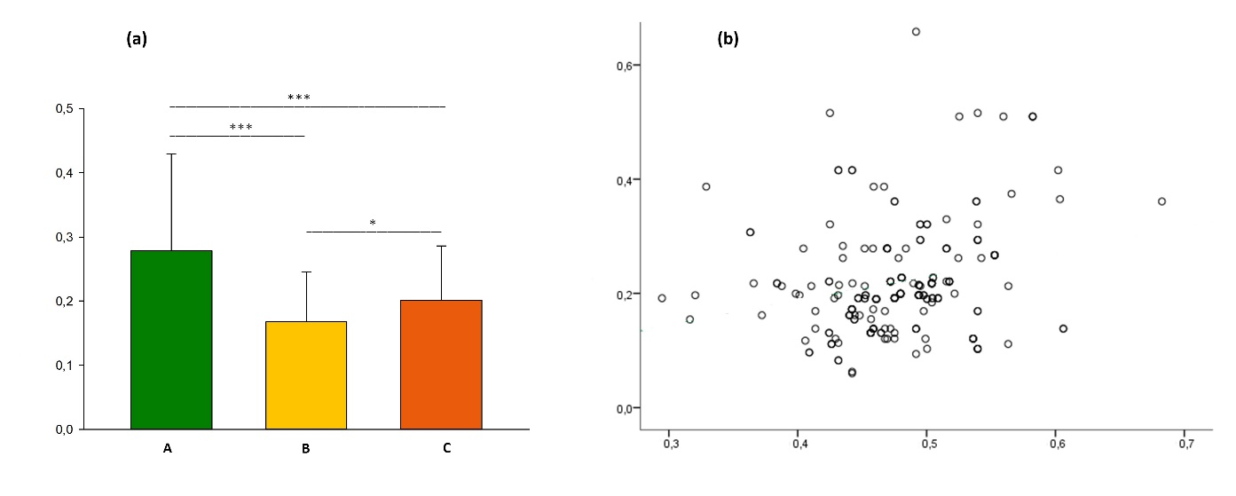
Figure (a) example of coloured figure and (b) example of grey-scale figure
)

